[--->Step 1: I login as an admin user[FAILED]<---]
  
[--->Failed Reason:
org.openqa.selenium.InvalidCookieDomainException: invalid cookie domain
(Session info: chrome=100.0.4896.127)
Build info: version: '4.6.0', revision: '79f1c02ae20'
System info: os.name: 'Mac OS X', os.arch: 'aarch64', os.version: '13.0.1', java.version: '19'
Driver info: org.openqa.selenium.remote.RemoteWebDriver$ByteBuddy$p9E81lSg
Command: [5b339d04ecbc6dc7fde01b1efa7b641f, addCookie {cookie=DISABLE_DB_PROFILER=1; path=/}]
Capabilities {acceptInsecureCerts: false, browserName: chrome, browserVersion: 100.0.4896.127, chrome: {chromedriverVersion: 100.0.4896.60 (6a5d10861ce8..., userDataDir: C:\Users\ltuser\AppData\Loc...}, goog:chromeOptions: {debuggerAddress: localhost:59697}, goog:loggingPrefs: {browser: ALL}, networkConnectionEnabled: false, pageLoadStrategy: normal, performance: false, platformName: WINDOWS, proxy: Proxy(), se:cdpVersion: 100.0.4896.127, setWindowRect: true, strictFileInteractability: false, timeouts: {implicit: 0, pageLoad: 300000, script: 30000}, unhandledPromptBehavior: dismiss and notify, video: true, webauthn:extension:credBlob: true, webauthn:extension:largeBlob: true, webauthn:virtualAuthenticators: true}
Session ID: 5b339d04ecbc6dc7fde01b1efa7b641f
at java.base/jdk.internal.reflect.DirectConstructorHandleAccessor.newInstance(DirectConstructorHandleAccessor.java:67)
at java.base/java.lang.reflect.Constructor.newInstanceWithCaller(Constructor.java:500)
at java.base/java.lang.reflect.Constructor.newInstance(Constructor.java:484)
at org.openqa.selenium.remote.codec.w3c.W3CHttpResponseCodec.createException(W3CHttpResponseCodec.java:200)
at org.openqa.selenium.remote.codec.w3c.W3CHttpResponseCodec.decode(W3CHttpResponseCodec.java:133)
at org.openqa.selenium.remote.codec.w3c.W3CHttpResponseCodec.decode(W3CHttpResponseCodec.java:53)
at java.base/java.util.function.Function.lambda$andThen$1(Function.java:88)
at org.openqa.selenium.remote.RemoteWebDriverBuilder.lambda$createExecutor$12(RemoteWebDriverBuilder.java:450)
at org.openqa.selenium.remote.RemoteWebDriverBuilder.lambda$createExecutor$13(RemoteWebDriverBuilder.java:456)
at org.openqa.selenium.remote.RemoteWebDriverBuilder.lambda$createExecutor$14(RemoteWebDriverBuilder.java:460)
at org.openqa.selenium.remote.RemoteWebDriverBuilder.lambda$createExecutor$15(RemoteWebDriverBuilder.java:469)
at org.openqa.selenium.remote.RemoteWebDriver.execute(RemoteWebDriver.java:541)
at org.openqa.selenium.remote.RemoteWebDriver$RemoteWebDriverOptions.addCookie(RemoteWebDriver.java:768)
at com.resumelibrary.utilities.Utility.setCookie(Utility.java:123)
at com.resumelibrary.utilities.Utility.disableSQLQuery(Utility.java:60)
at com.resumelibrary.utilities.Utility.getDriverWithUrl(Utility.java:54)
at com.resumelibrary.utilities.Utility.loadAdminHomePage(Utility.java:82)
at com.resumelibrary.admintest.misc.MiscPage.loginAsAdminUser(MiscPage.java:115)
at com.resumelibrary.cucumber.stepdefinitions.admin.misc.Misc.iLoginAsAnAdminUser(Misc.java:31)
at ✽.I login as an admin user(file:///Users/shubhamr/Desktop/rl-selenium-web/./src/test/java/resources/featurefiles/aaajobposting/AADataSetup.feature:6)
<---]  
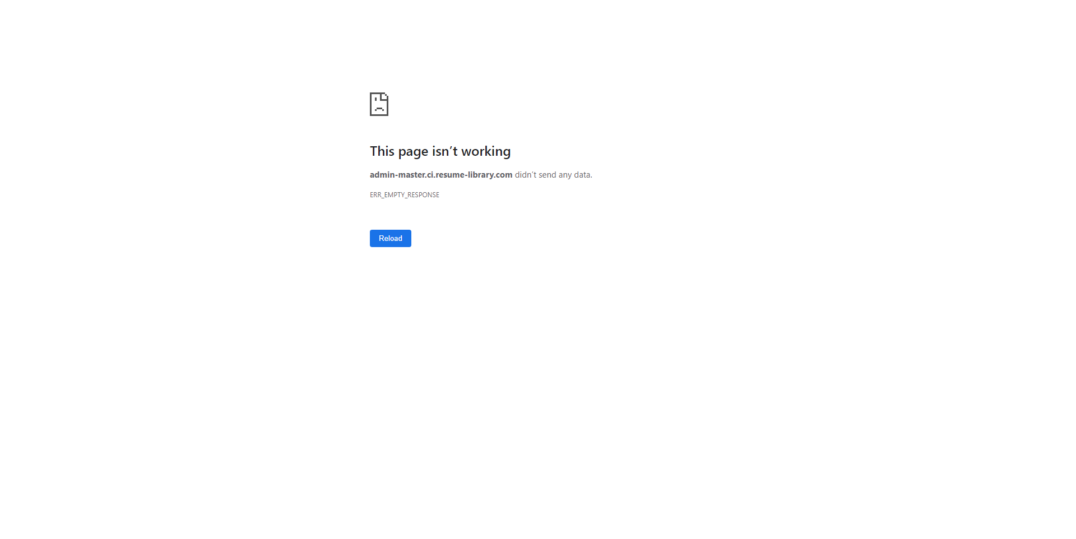

[--->Step 2: I navigate to page on admin "Account 1478"[SKIPPED]<---]

[--->Step 3: I click on product details Edit button[SKIPPED]<---]

[--->Step 4: the job posting spend type is "ACCOUNT" not "CLIENT"[SKIPPED]<---]